**Introduction:**

BrainVita (also known as Peg Solitaire) is a classic mind game, played by a single player. The standard game fills the entire board with marbles except for a single hole. The objective is to empty the entire board except for a single marble by strictly following the rules.

**Board Configuration:**

The board consists of holes which can hold marbles. All positions, except one, have marbles placed in them at the start of the game.

* A valid move for a marble is moving it from its position to an empty position (which is two positions away, horizontally, or vertically) by jumping over a non-empty position.
* The marble in the 'jumped' position is removed from the board.
* The game ends when there is no valid move possible.

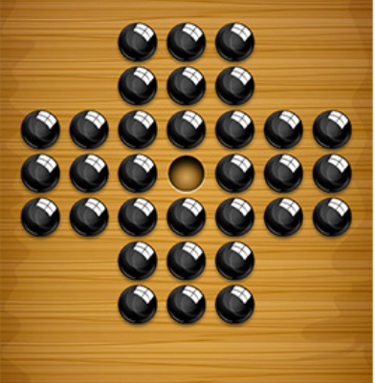

**Problem Statement:**

Most of the people get confused while playing this game that which step to take now to make plus point to be the winner of game because on every step the rules must be strictly followed and hence a human based on his thinking and analyzing capacity can evaluate the step which is to be taken to some extent only and can’t predict accuracy most of the time.

**Motivation/Usability/Purpose:**

As this is a brain game so the players of this game will definitely spend the time and energy in solving the game. But when they are stuck at some point having multiple options, but they are unable to make sure which step will lead to the winning state and will try to evaluate options, so this calculation or evaluation of a steps can be a time-consuming task for a human. So, to save evaluation time there should be a feature which could show accuracy of step.

**Proposed Solution:**

The proposed solution to the mentioned problem is an Agent/AI based program incorporated in the game as a feature which has ability to evaluate steps to the last valid move on the board by applying next steps based on player’s previous taken steps. It will estimate the accuracy of each option towards winning state and show it to the player and hence player can decide which step to apply based on the options’ weightage estimated by program. Moreover, it will also be able to suggest the next step to the player from the current state if there’s any valid move.

**Contribution of proposal/Beneficiaries:**

Players who are stuck at a state, can now find the next step/move leading to the winning state very easily just by activating this feature. More importantly they can save time evaluating a step and select most accurate option from multiple available options very easily. Even beginners can play and learn this game by following the steps suggested by the agent.

**References:**

1. [Brainvita (itgurussoftware.com)](http://brainvita.itgurussoftware.com/?msclkid=4ad7dcbea77b11ec88f21152aeb5c79e)